 NARROGIN SENIOR HIGH SCHOOL 

English ATAR Year 11
Student:
Date handed out: Monday 22nd June 2020
Date Due: Friday 26th June 2020
Assessment Type: Responding
Task 15

Answer the questions from the Semester One examination in short answer responses of 250-300 words per response.

The expectation is your response will be significantly improved as you have:
- The marking key
- Feedback on your responses
- Teacher input regarding each text and question
- Four periods to work on three responses
- Access to teacher support while you are working on the responses
Time allocation: Four periods in class.

Weighting: 5%

Mark: / 30

To be assessed for this task you must submit: | Date Due | YES | NO
Short answer responses | Friday 26th June 2020
The original responses and Marking Key from the examination | Friday 26th June 2020
A reflection that itemises AND explains what you have learnt about Responding to Short Answer Responses. Half to one page. | Friday 26th June 2020
Section One: Comprehending 30% (30 Marks)
The focus in this section should be on the candidate’s comprehension of the examination texts and application of analytical skills. Higher marks should be given to candidates who can respond clearly to the question, provide insightful comments about texts, sustain a point of view and use textual evidence to support a point.
Question 1 (10 marks)
Analyse how language features and conventions shape representations of identity in Text 1.
Text 1: An extract from the novel The Leavers by American author Lisa Ko published in 2017.
Suggested mark allocation for Question 1 | Marks
The quality and number of points made in relation to the question.  Language features  - Descriptive language that describes different settings, observations, characters.  - Imagery, mood and atmosphere of places, representations of people.  - Variation of syntax to engage the reader.  - Language choices such as ‘noodley’ that signify cultural difference in perceptions for the child.  - Punctuation for effect such as rhetorical questions.  - Direct speech that shows the disconnect of a phone call, relationships.  - Selection of detail that reinforce feelings of difference and alienation.  - Names that denote being foreign, or nicknames that convey affection.  - Juxtaposition of words, ideas, places, living conditions and lifestyles.  - Emotive language ‘dumped back into’. Onomatopoeia supports characterisation.  - Personification, analogy ‘the way a plant arched up…’. | 0 – 3
Conventions  - The setting of Manhattan Chinatown in New York which is juxtaposed with his grandfather’s village in Minjiang.  - Point of view - third person which tells us about the boy’s circumstances, feelings of displacement, bewilderment.  - Characterisation; the boy, his mother and grandfather; migrant life.  - Plot elements that show shifts of setting, events, actions and interactions.  - Ideas and the use of time, values, attitudes, customs. | 0 – 3
Representations of identity  - The representation of migration from a child’s point of view, his sense of self which is strongly grounded in his Asian heritage.  - Migrant identity. The hard life of many Asian migrants in New York who must work long hours to support families back home.  - Cultural differences of village life in Minjiang vs Americans in New York city.  - Relationships that show close bonds between the boy and his grandfather, his attachment to the village he has come from, the influences on his sense of belonging and identity, the routines that provide stability and security.  - The alienation that comes from a clash of cultures, language barriers, unfamiliarity of environment, displacement, poverty.  - The idea that identity is based on close family bonds, cultural acceptance and not simply being in a place. | 0 – 2
Expression  The extent to which the candidate expresses their responses clearly and concisely and integrates examples and/or brief quotes to support their response. | 0 – 2
Total | 10

Question 2 (10 marks)
Explain how persuasive techniques communicate opinion to target an audience in Text 2.

Text 2: Article extract ‘Should less-wealthy nations donate to our bushfire’s recovery?’

Suggested mark allocation for Question 2 | Marks
The quality and number of points made in relation to the question.  Persuasive techniques  - The title of the article which sets out the issue of aid.  - First person point of view, anecdote.  - Variation of syntax to engage interest, flow of article.  - Tone to communicate opinion, outrage or disapproval, disbelief, assertions.  - Punctuation for effect, rhetorical questions, alliteration, repetition for emphasis.  - References to professional experience, to show credibility.  - Inclusive and emotive language to persuade.  - Descriptive language to position emotions, selection of detail, imagery.  - Direct speech to directly address readers.  - Juxtaposition to show differences in nation equality.  - Facts. | 0 – 4
Opinion  - That Australia is rich enough to pay for its own natural disasters and should not expect poorer countries to contribute.  - Other wealthy nations should rather donate to disasters in those countries where there is poverty and no access to social media rather than to Australians.  - Millions of people in poorer nations need more representation and advocacy for aid. Poor countries have no real voice or human rights and since the writer worked for the UN he is qualified to express his opinion.  - We have the resources, community engagement to help ourselves before we look elsewhere for aid. | 0 – 3
Target audience  The writer is addressing Australian readers of The New Daily. | 0 – 1
Expression  The extent to which the candidate expresses their responses clearly and concisely and integrates examples and/or brief quotes to support their response. | 0 – 2
Total | 10

Question 3 (10 marks)
Show how Text 3 represents similar ideas and values to Text 2 and evaluate differences.
Text 3: A black and white copy of the cover of the Australian Who magazine published in 2020.
Suggested mark allocation for Question 3 | Marks
The quality and number of points made in relation to the question.  Similar Ideas  - Australians helping Australians in times of crisis.  - Bushfires have impacted our wildlife and communities.  - Australian celebrities can help raise funds to provide relief.  Similar Values  - Community spirit of generosity, compassion, empathy.  - Of ‘mateship’ - Australians helping battlers.  - Public responsibility and civic duty.  - Both contexts relate to Australian values. | 0 – 2
Representation  - The brand aligns itself with the generous spirit of Australians as reflected by choice of visuals and wording.  - Montage of photographs which conveys loss but also community kindness.  - The font which is capitalised and strategically placed for effect.  - The division, bleeding of panels which reveal experiences of the bushfire disaster to position response.  - Composition which foregrounds Celeste Barber an Australian celebrity who raised millions for those impacted by bushfire.  - Dress and symbolic codes, direction of gaze to show values such as respectability, marriage, a willingness to serve and be proactive.  - Thumbnails on the right which show celebrity endorsement of fundraising.  - A layout that communicates gossip, information and ideas expected by readers.  - Language features: punctuation for effect, alliteration, repetition, metaphor, emotive language, juxtaposition.  - Ideas about being proactive, leading by example, heroism, hope, trauma and loss, community spirit all engage the viewer’s feelings (and motivate further donations). | 0 – 4
Differences  Evaluation of differences requires subjective judgement.  - Mediums: Text 2 is an online article; Text 3 is a magazine cover and uses visuals. The persuasive techniques are different.  - Purpose: Text 2 expresses opinion, Text 3 wants to sell magazines and align its brand with a good cause.  - The magazine cover features celebrities helping who are not Australian (Pink) whereas in Text 2 the emphasis is on Australians helping Australians.  - The audience is different – Text 1 appeals to online readers and Text 2 to magazine readers, fans of Celeste Barber and celebrity gossip. | 0 – 2
Expression  The extent to which the candidate expresses their responses clearly and concisely and integrates examples and/or brief quotes to support their response. | 0 – 2
Total | 10

Question 1 (10 marks)
Analyse how language features and conventions shape representations of identity in Text 1.

Text 1
This is an extract from the novel The Leavers by American author Lisa Ko, published in 2017.

Her hand was foreign in his; he was used to his grandfather’s warmer grip and more deliberate walk. His mother was too fast, too loud, like the American city he’d been dumped back into, and Deming missed the village – its muted gradients of grass and water, greens and blues, burgundies and greys. New York City was shiny, sharp, a riot of colours, and everywhere the indecipherable clatter of English. His eyes ached. His ears filled with noise. The air was so cold it hurt to inhale, and the sky was crammed with buildings. He’d sought comfort in something familiar. He heard melodies in everything, his body gravitating to rhythm the way a plant arched up to the light. Crossing Bowery Street, he felt the soothing repetition of his feet hitting the sidewalk, his left hand connected to his mother’s right, his two steps to her one. She launched into the crosswalk. It was her one day off in two weeks. Deming examined the sidewalk droppings, cigarette butts and smeary napkins and, exposed between chunks of ice, so much gum. Who chewed these grey-pink wads? He had never chewed gum and neither had his mother, to his knowledge, or any of her six roommates in their small apartment on Rutgers Street.

They stood before the subway map with its long, noodley lines. “So, what colour should we do today?” she asked. Deming studied the words he couldn’t read, the places he’d yet to go, and pointed to the purple route. He’d been born here, in Manhattan Chinatown, but his mother had sent him to live with his grandfather when he was a year old, in the village where she had grown up. It was Yi Gong who starred in Deming’s earliest memories, who called him “Little Fatty” and taught him how to paddle a boat, collect a chicken egg, and gut a fish with the tip of a rusty knife. There were other children like him in Minjiang, American-born, cared for by grandparents, with parents they only knew from the telephone. “I’ll send for you,” the voice would say, but why would he want to go live with a voice, leave what he knew for a person he didn’t remember? All he had then was a picture, where he was a scowling baby and his mother’s face was obscured by a shadow. Each morning he awoke to the cht cht cht, of Yi Gong sweeping the front of their house on 3 Alley, the old man’s wheezing, silver smoke rings dissolving skyward, until the morning Yi Gong didn’t wake up.

And then, Deming was on a plane next to an uncle he would never see again, and a woman was hugging him in a cold apartment full of bunk beds, her face only familiar because it resembled his. He wanted to go home but she told him the bunk bed was home. He didn’t want to listen, but she was all he had. That was two weeks ago. Now he sat in a classroom every day at a school on Henry Street, not understanding anything his teachers said, while his mother sewed shirts at a factory.

Question 2 (10 marks)
Explain how persuasive techniques communicate opinion to target an audience in Text 2.

Text 2
An extract from the article ‘Should less-wealthy nations donate to our bushfire’s recovery?’ by Professor Andrew MacLeod, The New Daily, 2020.

I understand the tragedy. Australia is facing one of the fronts of climate change and we are facing a terrible fire season. But to see us appealing for funds from Cambodia? Back when I worked in humanitarian assistance for the United Nations, we had a saying: “Don’t give aid to the loudest voice. Listen to the people who cannot speak.” While Australians are communicating our plight to the rest of the world, the same cannot be said for those suffering fire in Congo, humanitarian catastrophes in Yemen, natural disasters in Philippines, Puerto Rico and the ongoing refugee crisis affecting at least 65 million people around the world.

Australians are wealthy, allowing us to reach out to other countries and engage their empathy to help us. Australia is a rich country and, by some measures, the richest in the world. We are a loud voice. But our voice also has responsibility. The bushfires in Australia have mobilised the generosity of Australians and foreigners alike to donate to our emergency and its aftermath. People are rightly concerned and impacted about the millions of hectares being burnt, the carbon being emitted into the atmosphere, the tragic sight of burned koalas and fleeing kangaroos. Livelihoods, houses and lifestyles are being harmed or destroyed too. But I believe Australia has the resources and Australia can and should pay for itself. There are millions of victims of natural disasters and climate in other countries whose voices are not heard. These other millions may not be able to afford the publicity and may not be able to garner the sympathy and empathy of other rich western countries. They may not be able to post on social media photos of fires, floods, or animals suffering horrible deaths because they may not have access to social media.

I am not saying we should avoid partnerships with foreign fire services to share equipment in the off season. These are sensible partnerships. I am also not saying that individuals should be left to look after themselves. Australians are generous people and should donate to Australia. Our communities can and should come together. Those inside Australia should keep donating and helping our own people. But for those outside Australia I say: “Please donate to disasters where victims cannot afford smartphones, internet or perhaps even enough food.” We should not be using our tragedy to divert funds or take funds from those massively less well off than us – like those in Cambodia. Australia is a rich country. We can and should pay for ourselves.

Question 3 (10 marks)
Show how Text 3 represents similar ideas and values to Text 2 and evaluate differences.

Text 3
A copy of the Australian Who magazine cover published in 2020.
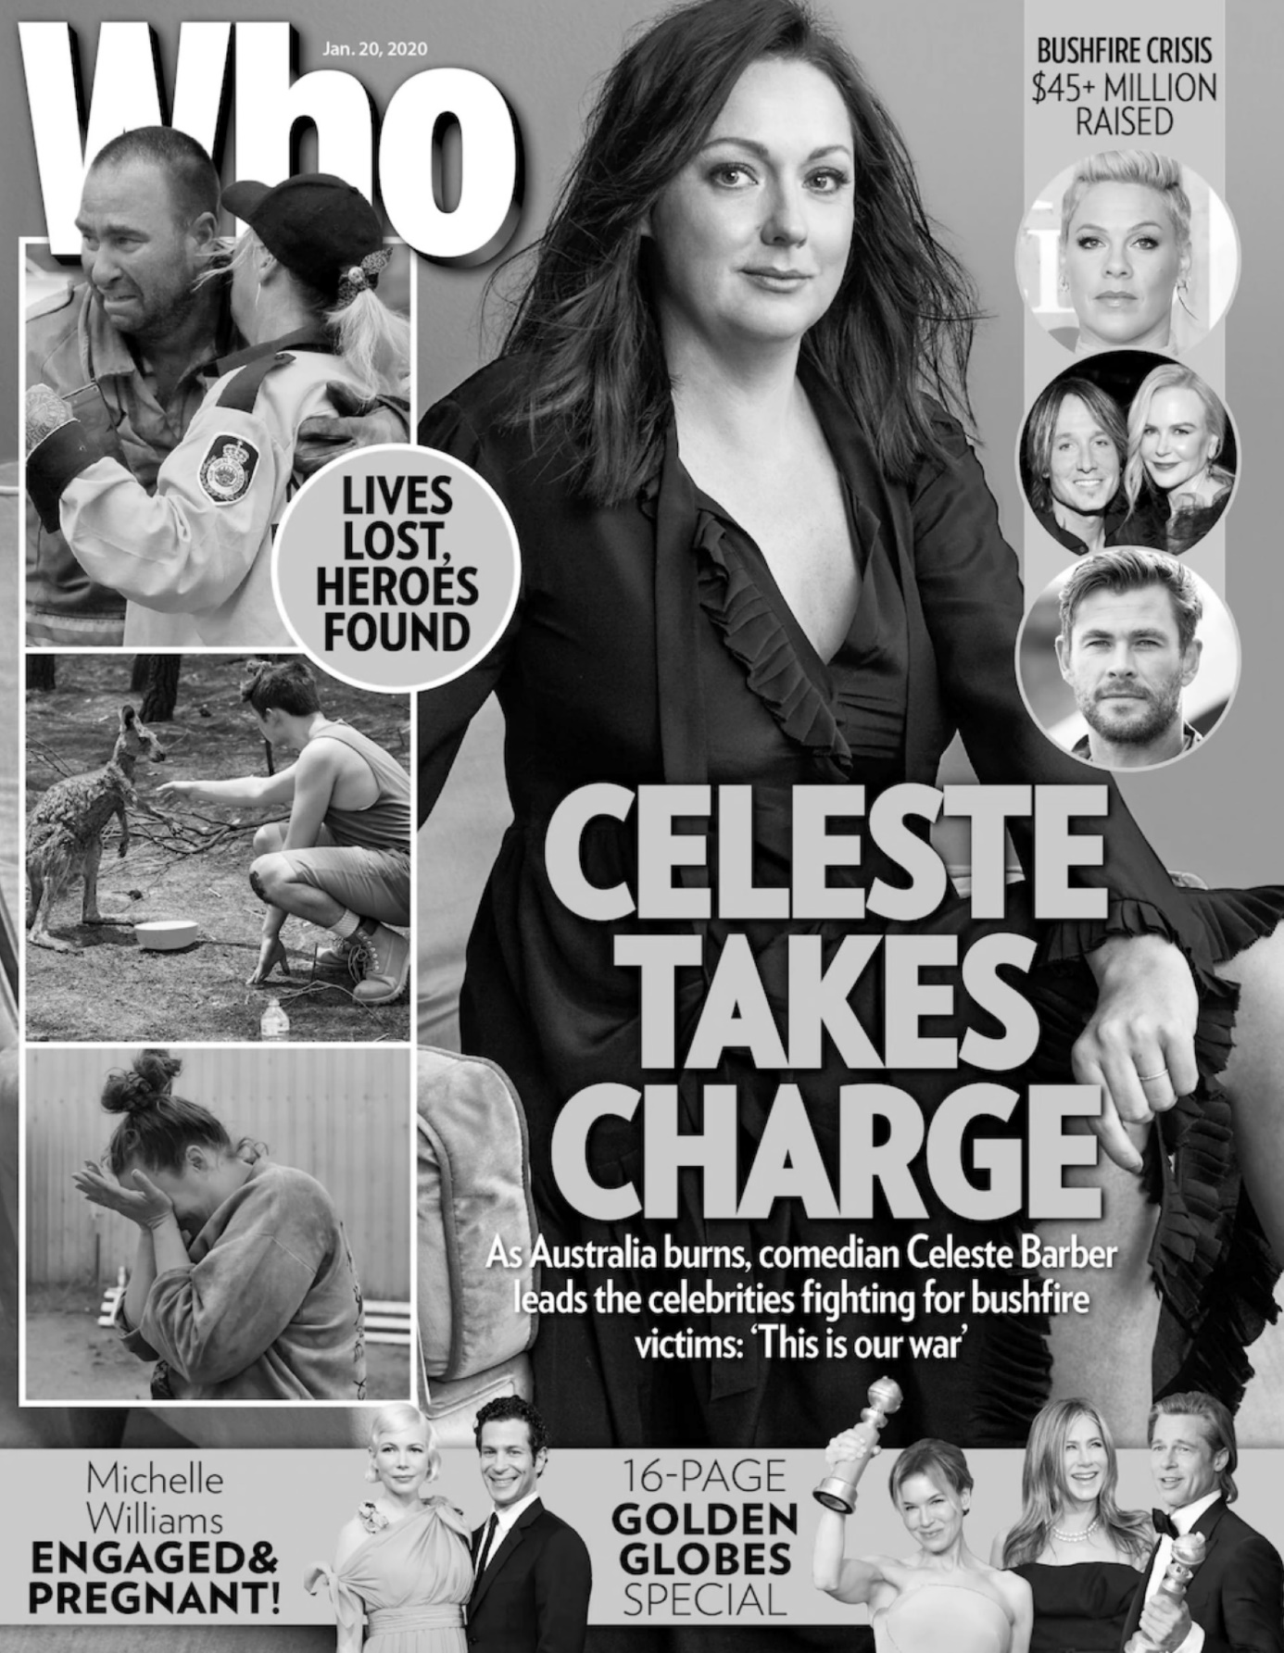
End of Section One

